Parents' Right to Withdraw from 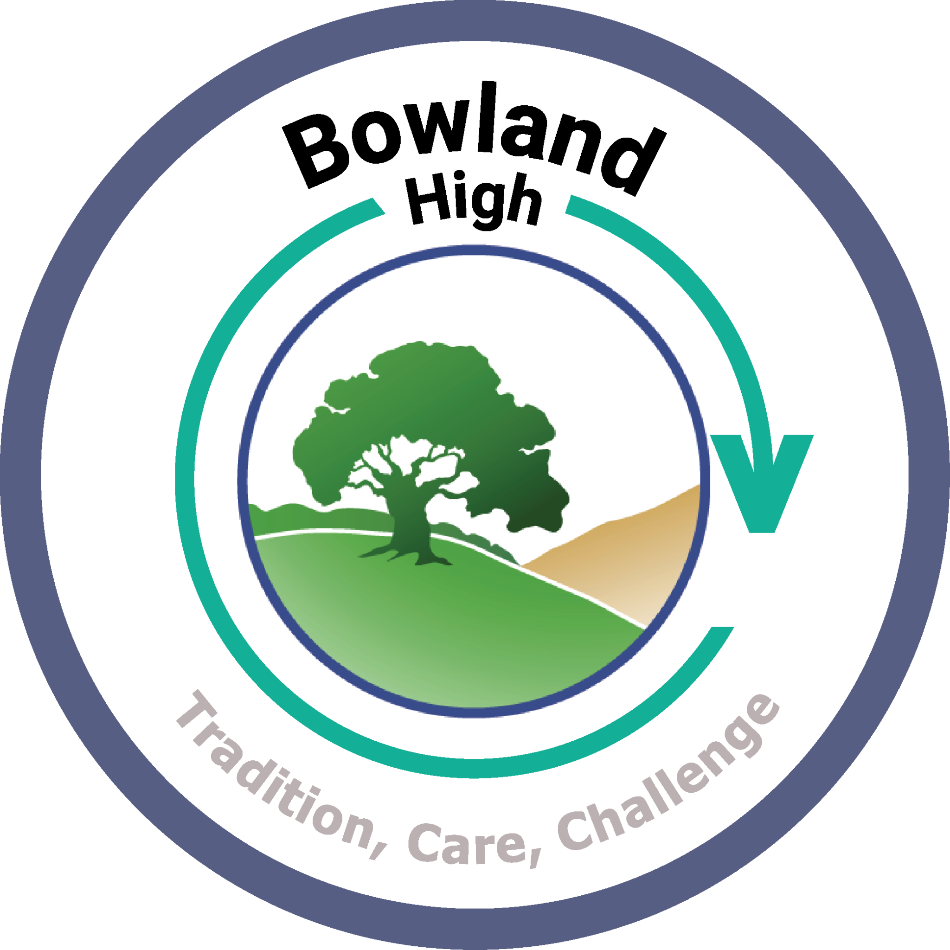Relationships and Sex Education (RSE)
At Bowland High School, we are committed to providing a high-quality PSHCE curriculum that helps pupils develop the knowledge, skills and understanding they need to stay healthy, safe and prepared for life in modern Britain.
Under current Department for Education guidance, there is no right to withdraw a child from the statutory elements of:
- Relationships Education
- Health Education
- Science Curriculum content
These areas are compulsory for all pupils and cover important topics such as healthy relationships, mental wellbeing, online safety, physical health, puberty and keeping safe.
Parents and carers do have the right to request that their child is withdrawn from some or all of the sex education elements delivered as part of Relationships and Sex Education (RSE) that fall outside of the National Curriculum for Science.
If a parent wishes to discuss withdrawing their child from sex education lessons, they should contact the school. The Headteacher will arrange a meeting to discuss:
- The nature and purpose of the curriculum content.
- The benefits of receiving this education alongside peers.
- Any concerns the parent may have.
- The implications of withdrawal.
The school will respect parents' legal right to request withdrawal from non-statutory sex education up to three terms before a young person turns 16. After this point, if a pupil wishes to receive sex education, the school must make arrangements for them to do so.
If a pupil is withdrawn from sex education lessons, the school will provide appropriate alternative supervised learning during that time.
We strongly encourage all pupils to participate in Relationships and Sex Education, as it plays an important role in helping young people develop healthy relationships, understand consent, recognise abuse and exploitation, access support services and make informed decisions as they grow into adulthood.
If you would like further information about our PSHCE or RSE curriculum, please contact Miss Hardisty at school.

