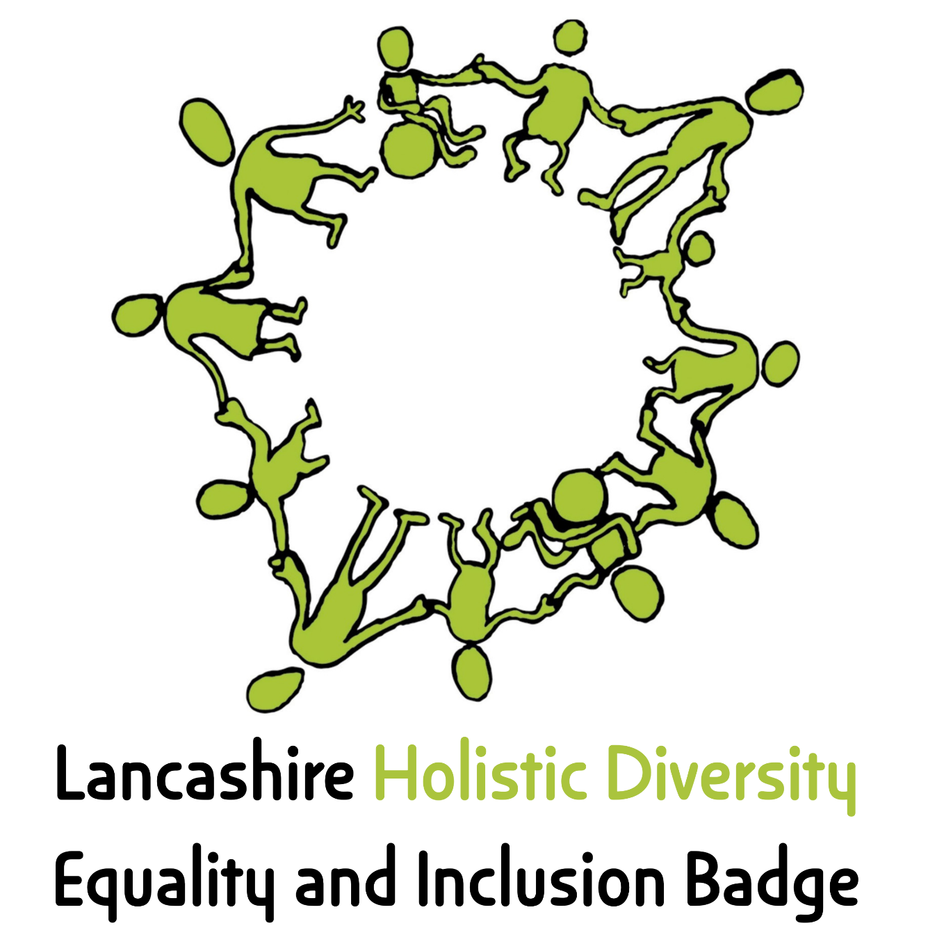
This is to certify that
Bowland High School

has successfully achieved the Lancashire Holistic Diversity Equality Badge

Signed: 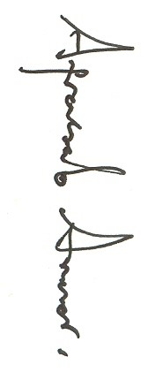 Date:17th April 2026

